AWS WAF & Service Manager
Task 1: AWS Web Application Firewall (AWS WAF)
Objective
Learn how AWS WAF protects web applications from common web attacks by creating a Web ACL and attaching it to an Application Load Balancer.

What is AWS WAF?
AWS Web Application Firewall (WAF) is a security service that protects web applications from attacks such as:
- SQL Injection (SQLi)
- Cross Site Scripting (XSS)
- Bot attacks
- HTTP Flood attacks
- Bad IP addresses
- Geographic restrictions
AWS WAF filters HTTP/HTTPS requests before they reach your application.

Real-Time Use Cases
Banking
Protect Internet Banking websites from hackers.
E-Commerce
Prevent fake login attempts and bots.
Government
Block requests from unauthorized countries.
Healthcare
Protect patient portals.
Education
Prevent DDoS attacks on online exam portals.

AWS WAF Architecture
Users
|
Internet
|
--------------------
| AWS WAF Web ACL |
--------------------
|
Application Load Balancer
|
----------------------------
| |
EC2 Instance EC2 Instance

Prerequisites
You should already have
- AWS Account
- Application Load Balancer
- Two EC2 Instances
- Security Groups
- Target Group

Step 1 Create a Web ACL
Open
AWS Console
Search
WAF & Shield
Click
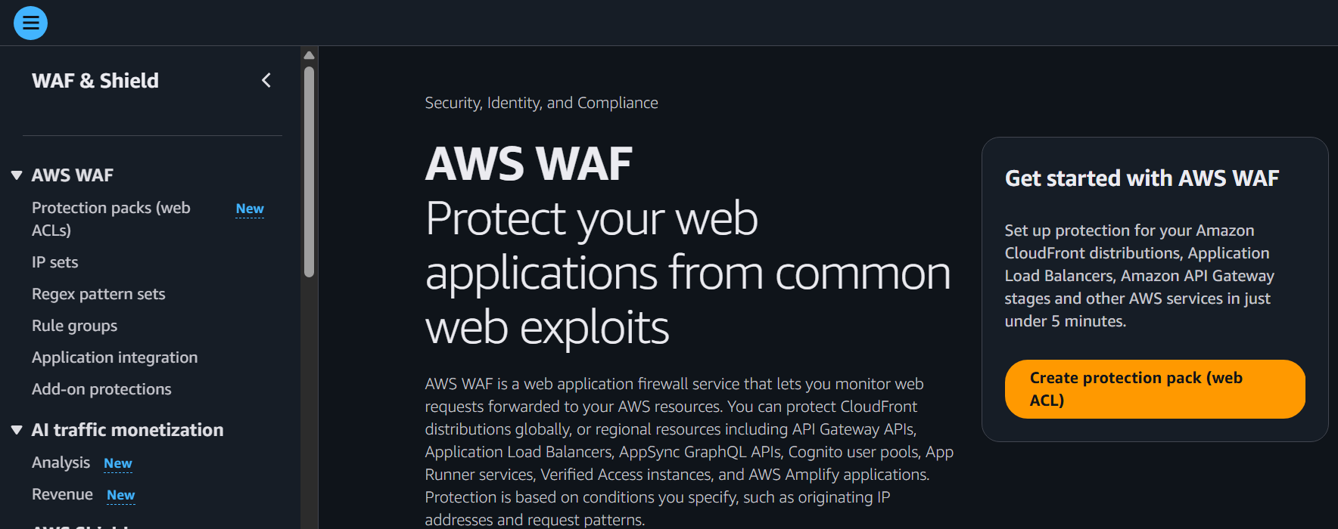
AWS WAF
Click
Create Web ACL
Create Web ACL Page
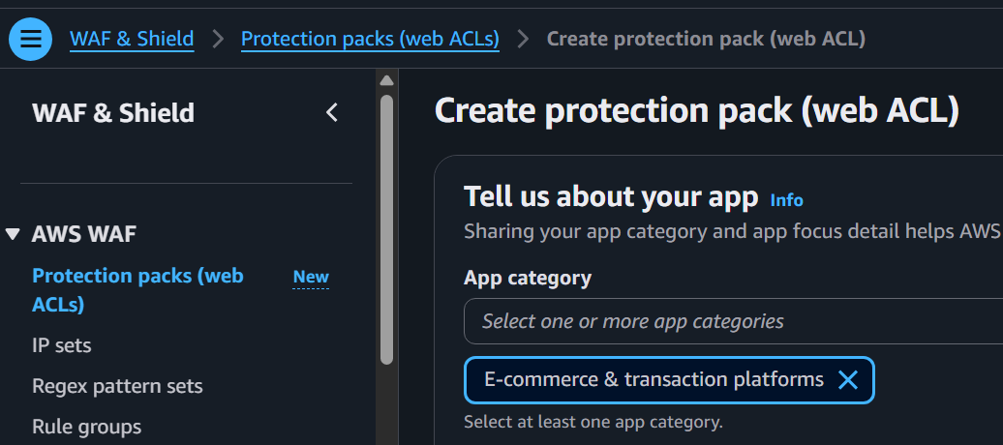
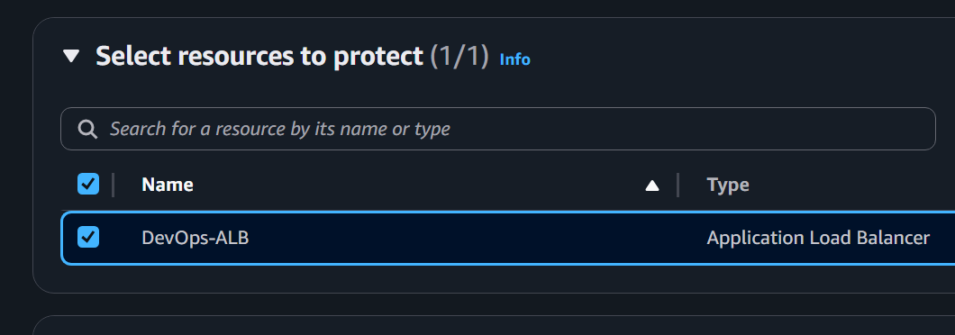
Step 2 Enter Web ACL Details
Name
DevOps-WebACL
Description
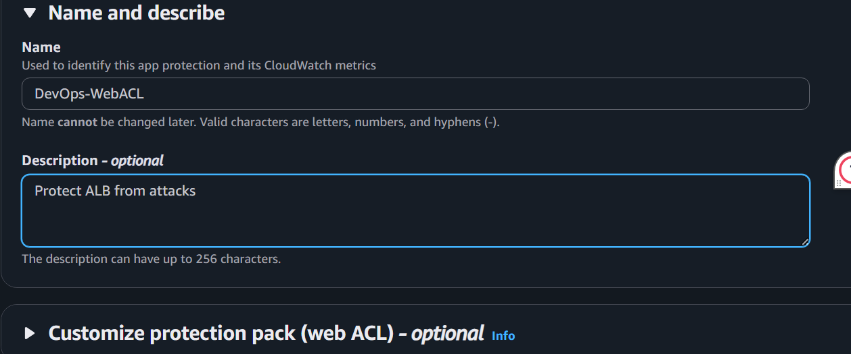
Protect ALB from attacks
Region
Choose your ALB Region
Example
US East (N. Virginia)

Step 3 Associate AWS Resource
Resource Type
Choose
Application Load Balancer
Select your ALB
Example
DevOps-ALB
Click
Next
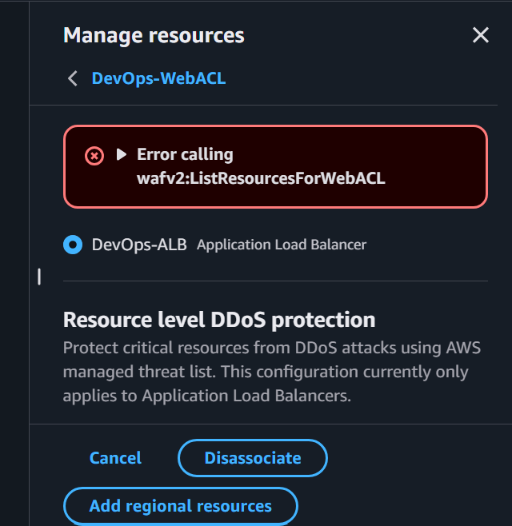
Associate Resource
Step 4 Add Rules
Click
You built it
Add Rules
Choose
Add Managed Rule Groups
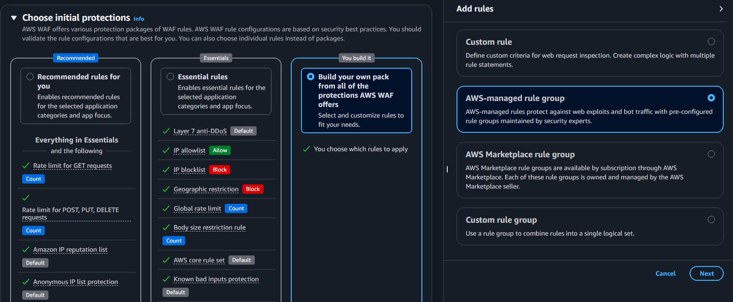

AWS provides ready-made security rules.
Select
✔ Core Rule Set
This protects against
- SQL Injection
- Cross Site Scripting
- Command Injection
- Local File Inclusion
- Remote File Inclusion
Click
Add Rules
Managed Rule Groups
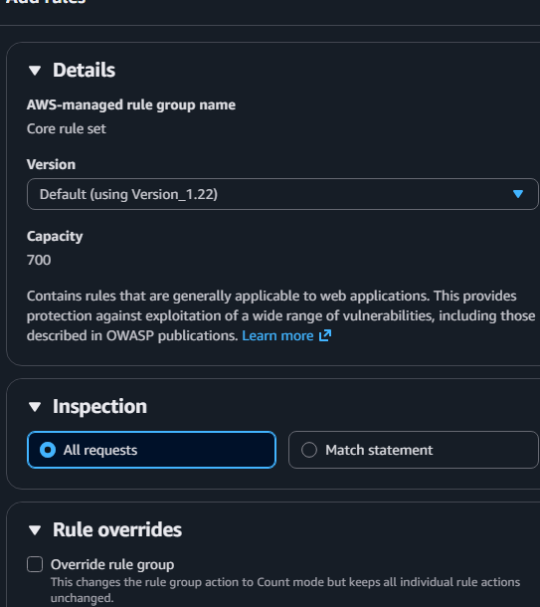

Step 5 Add Amazon IP Reputation List
Click
Add Managed Rules
Choose
Amazon IP Reputation List
This blocks
- Known malicious IPs
- Spam sources
- Bot networks
Click
Add Rule
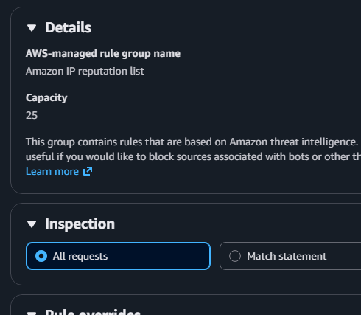
Amazon Reputation List
SQL Injection Rule Set
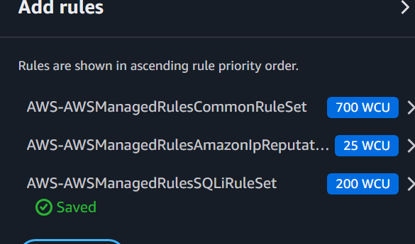

Step 6 Configure Rule Priority
Leave Default
Priority
1
2
3
Click
Next
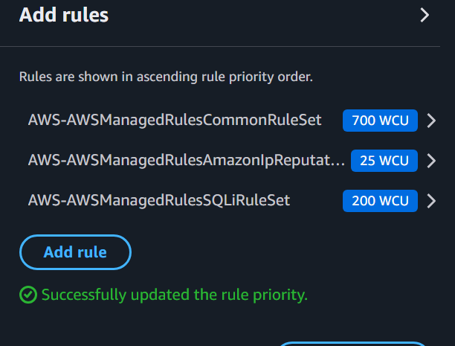
Step 7 Review
Verify
- Name
- Rules
- ALB Association
Click
Create Web ACL
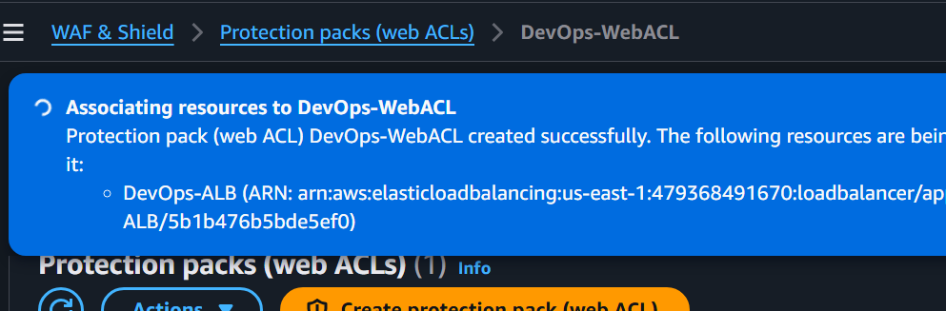

Step 8 Verify Association
The instruction:
Open Application Load Balancer → Description Tab → You should see "Protected by AWS WAF"
is based on the older AWS Console.
In the new AWS Console
AWS no longer displays "Protected by AWS WAF" in the ALB Description tab. Instead, the association is managed from the AWS WAF console.
How to verify the association now
Method 1 (Recommended)
Go to:
AWS WAF → Protection packs (Web ACLs) → DevOps-WebACL → Manage Resources
If you see:
- ✅ DevOps-ALB
- ✅ Application Load Balancer
- ✅ Disassociate
then the Web ACL is successfully associated with the ALB.

Test WAF
Browse your website
http://ALB-DNS
Website loads successfully.
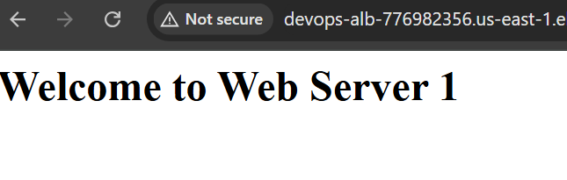
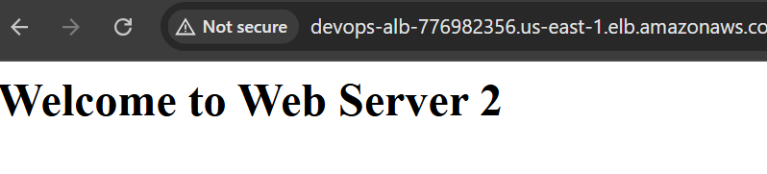

Try a fake SQL Injection in the URL
Example
http://ALB-DNS?id=' OR 1=1 --
AWS WAF should inspect and block suspicious requests based on managed rules.
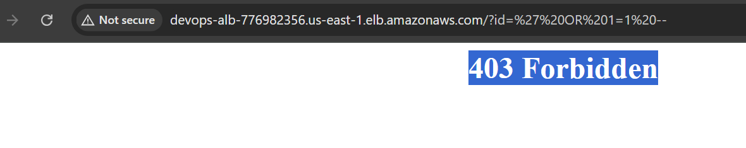

Monitoring
Open
↓
Metrics
↓
AWS WAF
Observe
- Allowed Requests
- Blocked Requests
- Count Requests
CloudWatch WAF Metrics
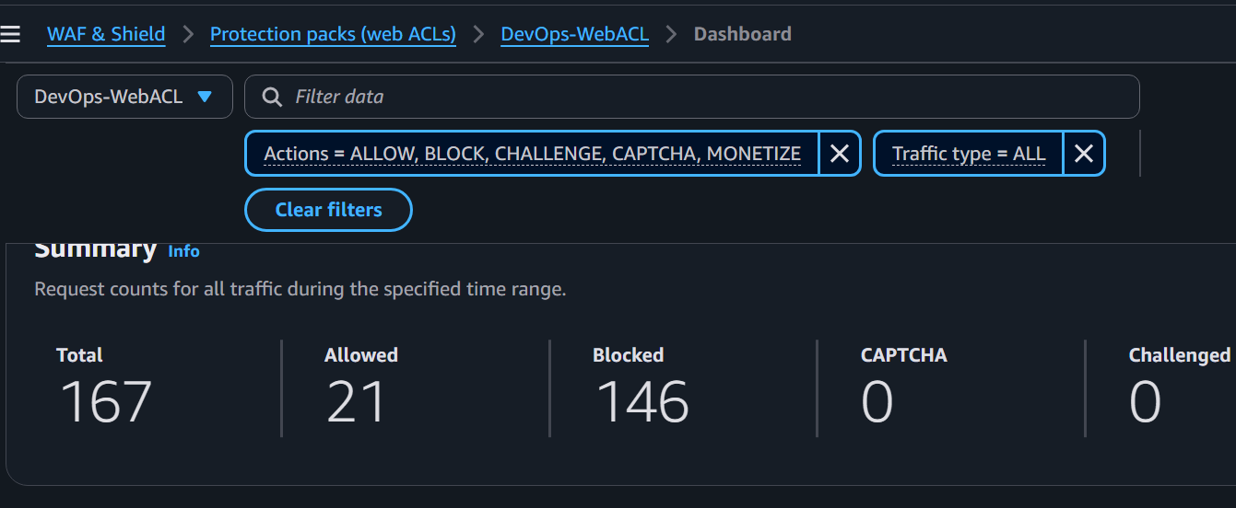
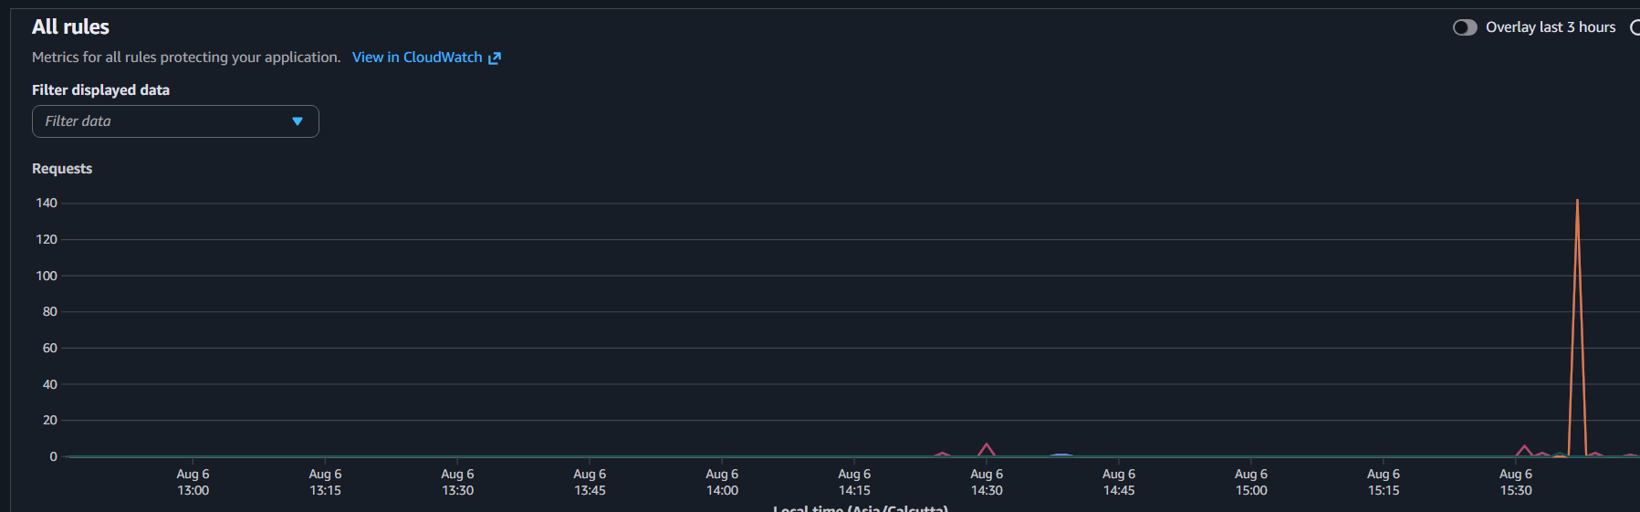

Architecture Summary
Users
|
AWS WAF
|
Application Load Balancer
|
Target Group
|
EC2

Observations
- Successfully created Web ACL.
- Attached Web ACL to ALB.
- Enabled AWS Managed Rules.
- Enabled IP Reputation List.
- CloudWatch metrics displayed request counts.
- Application remained accessible while suspicious requests were filtered.

Advantages
- Managed security rules.
- Protection against OWASP Top 10 attacks.
- Easy integration with ALB.
- Scalable.
- CloudWatch monitoring.

Disadvantages
- Additional AWS cost.
- Rule tuning may be required.
- Does not replace secure application coding.

AWS System Manager
What is AWS Systems Manager?
AWS Systems Manager (SSM) is a service that helps you centrally manage, monitor, and
operate your AWS resources (nodes) across AWS, on-premises, and multicloud
environments from a single console. It enables secure remote management, automation,
patching, command execution, and configuration management without needing to log in to
each server individually.
Benefits
• Centralized management
• Run commands remotely
• Secure access without SSH
• Automate administrative tasks
• Patch management
• Store configuration and secrets (Parameter Store)
Main Features
• Session Manager – Securely connect to EC2 without SSH.
• Run Command – Run commands on one or more EC2 instances.
• Parameter Store – Store configuration values and secrets.
• Patch Manager – Apply OS patches.
• Automation – Automate operational tasks.
Step 1: Open AWS Systems Manager
1. Sign in to the AWS Management Console.
2. Search for Systems Manager.
3. Open Systems Manager.
AWS Management Console
↓
Search: Systems Manager
↓
AWS Systems Manager
Step 2: Open Parameter Store
Systems Manager
↓
Application Tools
↓
Parameter Store
Step 3: Create a Parameter
Click Create parameter and enter:
Field Value
Name /myapp/db-password
Tier Standard
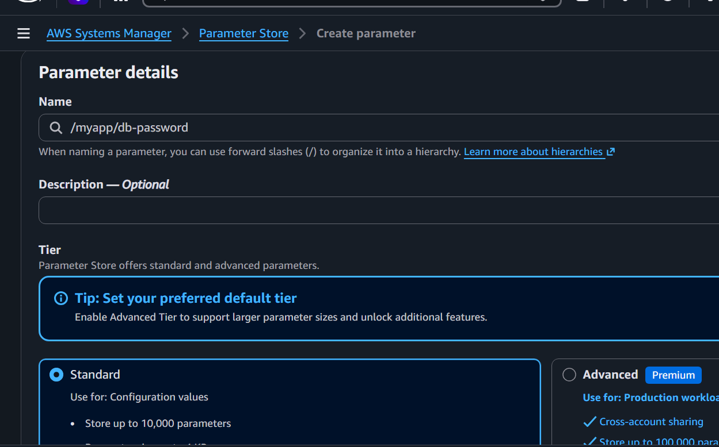
Type SecureString
KMS Key aws/ssm
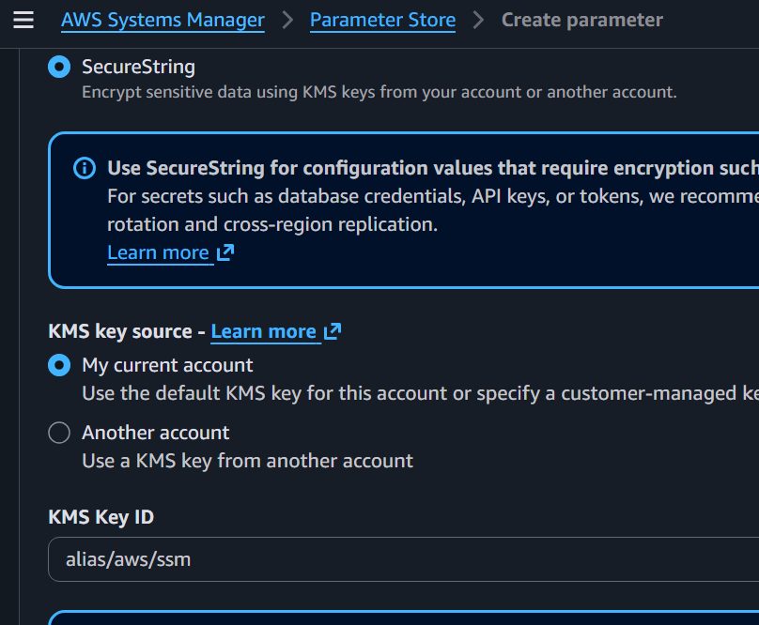
Value MyPassword@123
Click Create parameter.
Step 4: Verify the Parameter
• Open Parameter Store.
• Confirm that /myapp/db-password is listed.
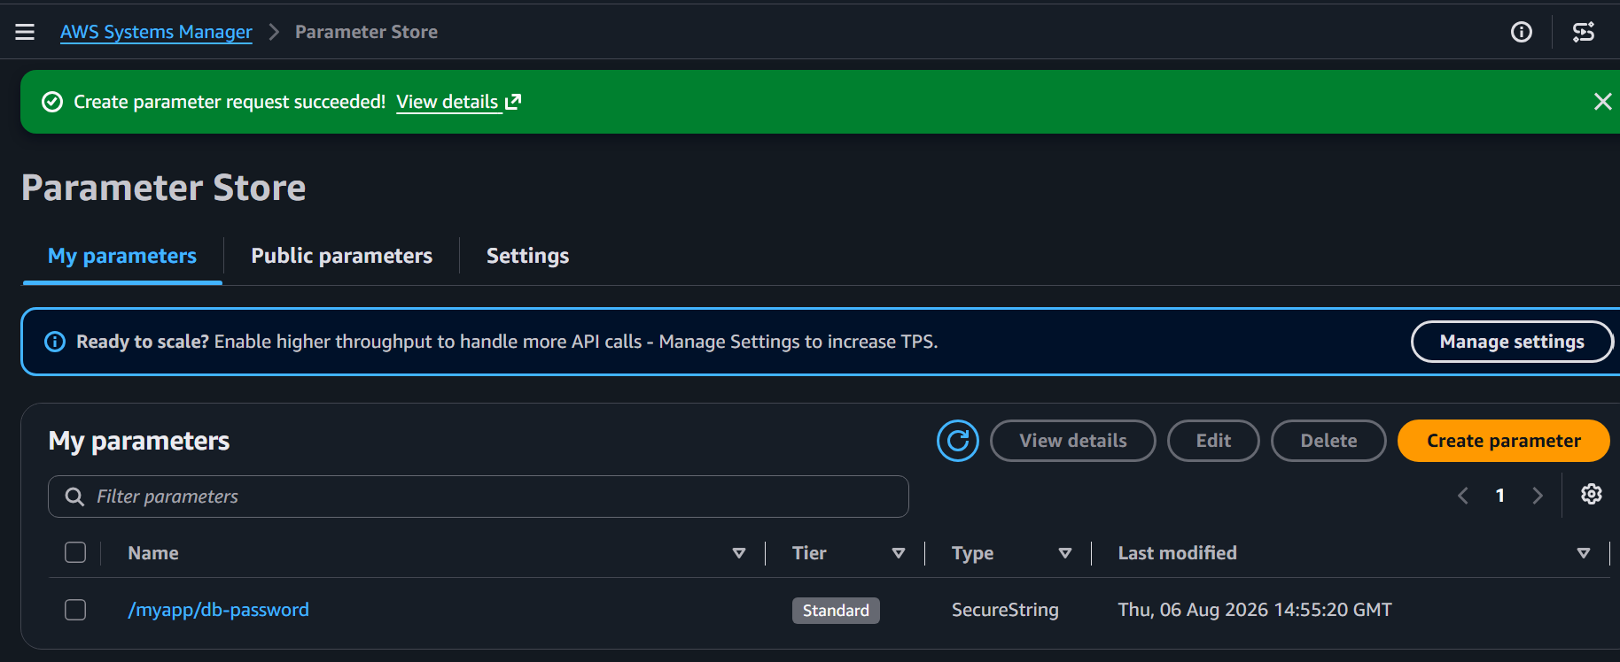
Step 5: Retrieve the Parameter
aws ssm get-parameter \
--name "/myapp/db-password" \
--with-decryption
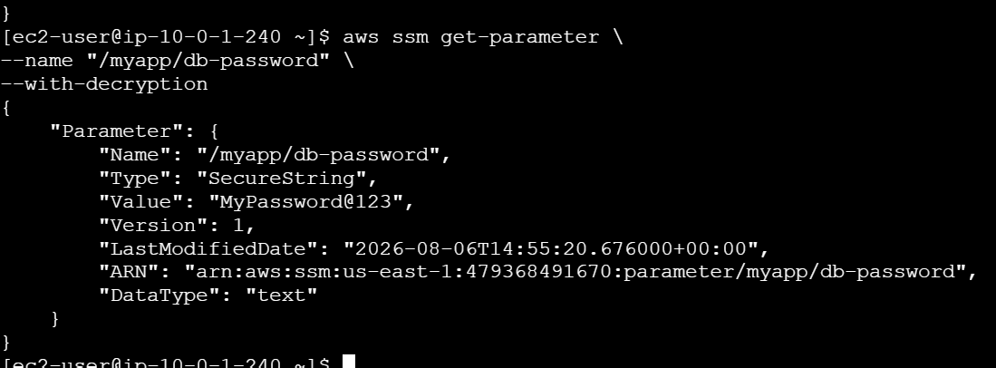

Step 6: Update the Parameter
aws ssm put-parameter \
--name "/myapp/db-password" \
--value "NewPassword@123" \
--type SecureString \
--overwrite
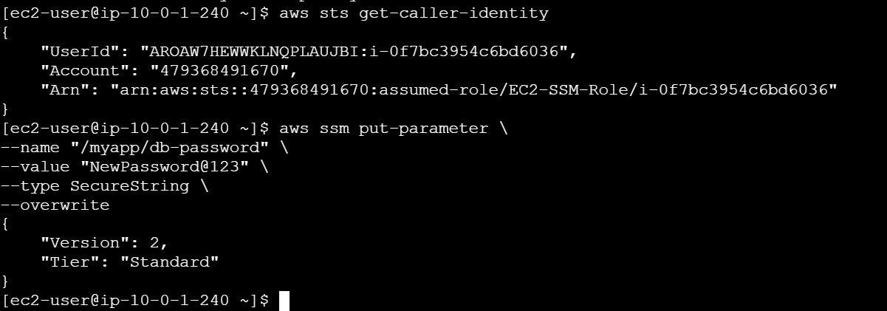
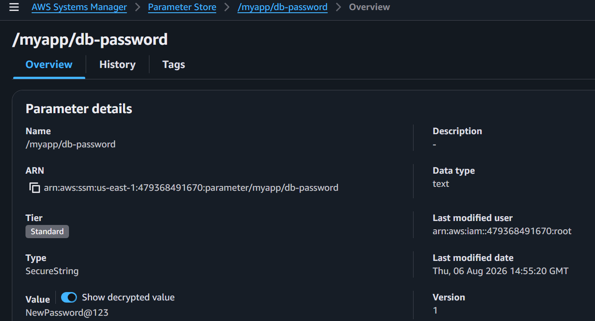
Step 7: Verify the Updated Value
aws ssm get-parameter \
--name "/myapp/db-password" \
--with-decryption
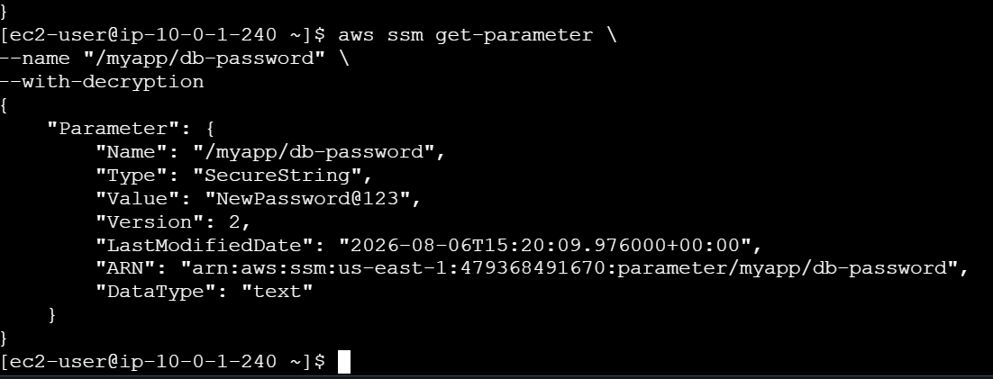
Step 8: Delete the Parameter
aws ssm delete-parameter \
--name "/myapp/db-password"
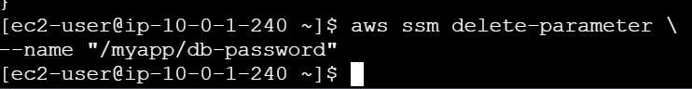
Step 9: Verify Deletion
• Refresh the Parameter Store page.
• Confirm the parameter is no longer listed.
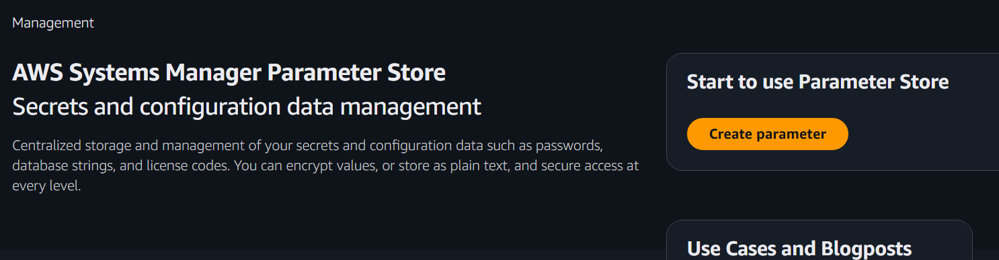
Lab Outcome
• Created a SecureString parameter.
• Retrieved it using the AWS CLI.
• Updated the parameter.
• Deleted the parameter successfully.

